**Project 2**

**Kevin McClard, Russell Haws, Preethi Dayanand**

Our topic will be UFOs. With the recent social media campaign of storming Area 51, and the United States government confirming the US Navy videos are real, a resurgence in understanding if we are the only intelligent life in the galaxy, or the universe, takes on additional significance.

The underlying questions we will work to address involve how reported sightings compare to what standard model scientists predict we might see. We want to go back in time to analyze data on reported sightings, who saw them, what they saw, where, and any statistical significance incorporated with these eyewitness accounts.

Below is a MongoDB view of our data; we will be working with SQLite since it is easier to use with Heroku.

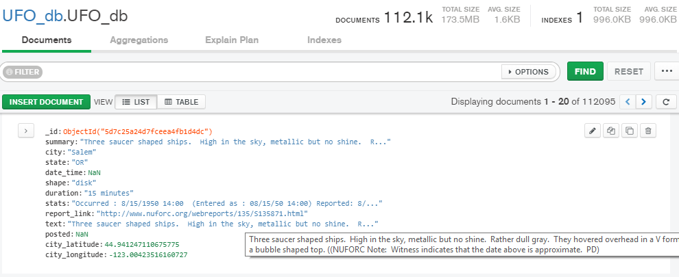

We plan to have a number of views of the data including a set of dynamic timelines showing how the reported sightings have changed over the years, utilizing both plotly and Leaflet. There will also be a statistical analysis of the natural language descriptions. We also have a US cities database that we can cross reference for population density if we have time.

The Github repository for this project is: <https://github.com/Gitpvd/Project-2--UFOs-and-Intelligent-Life>

A few screenshots that helped us define how we want to approach the topic:

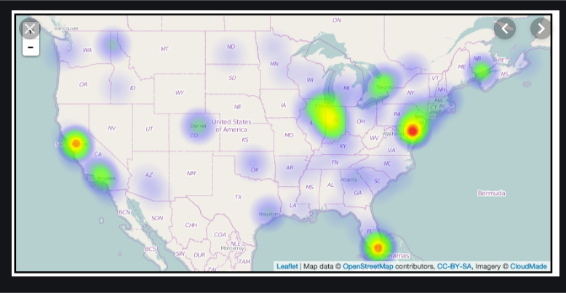

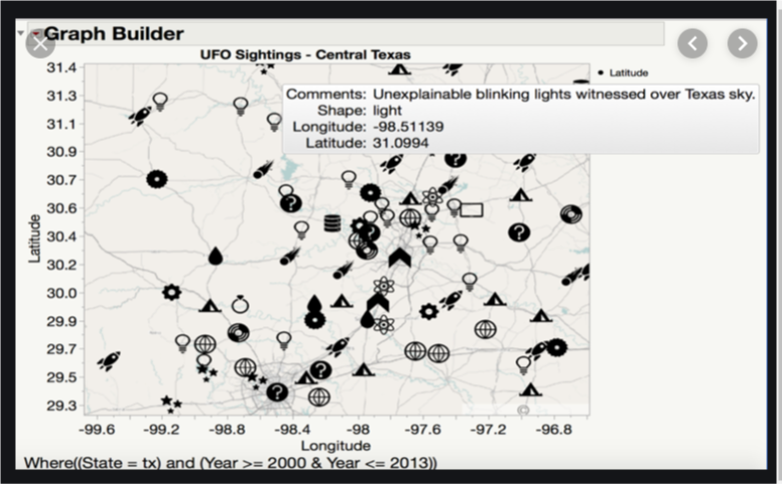

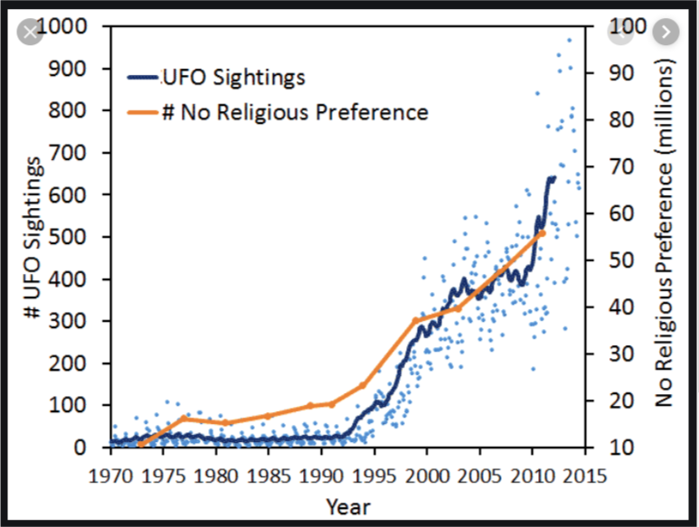

A rough sketch of what we would like to produce is below:

UFOs

The Truth Revealed

What have witnessed so far?

Time vs. Shape

Sightings Map

Additional content as inspired by project work and further discovery

Have we infact made contact?

Scientist predictions vs. sightings data 1

Scientist predictions vs. sightings data 1

Additional content as inspired by project work and further discovery